**Level Design Document for:**

*Marble Game: Highs and Lows*

All work Copyright ©2021

Written by Team AIE Production

Table of Contents

1.0 Revision History 4

2.0 Level Design Overview 4

2.1 Level Design concept 4

2.2 Gameplay Mechanics 4

2.3 Camera 4

3.0 Theme and Characters 5

3.1 Characters 5

3.2 Theme 5

4.0 Level Information 5

4.1 Level Location 5

4.2 Level Setting 5

4.3 Level Layout/Architecture 5

5.0 Level Design 5

5.1 Main Objectives 5

5.2 Optional Objectives 6

5.3 WOW Moments 6

5.4 2D Floor Plan 6

5.5 Level Progression 7

5.6 Player Experience 9

6.0 Art Style and Aesthetics 9

6.1 References 9

6.2 Lighting 9

6.3 SFX/Music 9

6.4 Particle FX 9

7.0 Level Asset List 9

8.0 Delivery Milestones 10

# 1.0 Revision History

<As you revise the document, list what was changed and when it was changed>

|  |  |
| --- | --- |
| Version | Description |
| 1.0 | Initial document |
| 2.0 | Changes to the following sections:   * Themes and Characters * Level Information * Level Design |
| 2.1 | Changes to level information |
| 2.2 | Changes to 4.1 and 6.4 |

# 2.0 Level Design Overview

## 2.1 Level Design concept

The level will consist of multiple paths that lead to the end goal. These paths are made up of ramps that will utilize the games own physics to build up speed and floating platforms for players to try to land on using the ramps.

## 2.2 Gameplay Mechanics

Movement

* Rolling
* Jumping

Momentum

* Building up speed overtime by rolling and jumping or falling
* Can be used to cross great distances in a short amount of time.

Collectables

* Used to increase total score.

## 2.3 Camera

* 3rd person camera

# 3.0 Theme and Characters

## 3.1 Characters

There are no “characters” in this level. Only inanimate objects.

## 3.2 Theme

The theme is a silly, fun toy factory. The player must navigate the marble run to reach the big spaceship at the end and start the launch sequence.

# 4.0 Level Information

## 4.1 Level Location

A fun, space themed toy store Right above the land that a new toy will be sold to.

## 4.2 Level Setting

A new toy is about to be released. The marble needs to reach the end of the level by using the ramps to cross great gaps to reach the button that will launch the new toy. Other toys are on standby on flying sales platforms.

## 4.3 Level Layout/Architecture

The layout of the level will resemble the layout of marble run sets. With ramps and tunnels of various colours.

# 5.0 Level Design

## 5.1 Main Objectives

To reach the end of the level by touching the last platform. There are multiple paths for players to take for players who either want a shorter running time or those who want to maximize their score.

## 5.2 Optional Objectives

* Fastest time
* Collecting items to increase score.

## 5.3 WOW Moments

* A big ramp that sends the player soaring.
* A funnel that drops the player showing off the end goal
* When the player reaches the end goal, a cutscene will play

## 5.4 2D Floor Plan

## 5.5 Level Progression

|  |  |  |  |  |  |  |  |  |  |  |  |  |
| --- | --- | --- | --- | --- | --- | --- | --- | --- | --- | --- | --- | --- |
| **Level:** Highs and lows |  | | Teach player about momentum | |  | |  | |  | | Split paths | |
| **Level Start (Section 1)** | platform leading to 1 ramp | | Ramp that leads to a funnel | | Funnel leads to a open that showcases the end goal | |  | |  | |  | |
| **End of level (Section 5)** |  | |  | |  | |  | |  | |  | |
|  |  | |  | |  | |  | |  | | Path 1: for more points | |
| **Mid-level (Section 2)** |  | |  | |  | | Player is dropped onto a platform | | 2 ramps lead off the platform | |  | |
|  |  | |  | |  | |  | |  | | Path 2: for better time | |
| **End of level (Section 4)** |  | |  | |  | |  | |  | |  | |
|  | |  | |  | |  | |  | |  | |
|  | |  | |  | |  | |  | |  | |
|  | |  | |  | |  | | A straight forward, wide platform with collectables on it | | Leads to the final platform | |
| Wider path that contains more collectables | | A ramp for players to build up momentum | | If Player has built up enough speed and momentum they can reach section 4 | | If players miss section 4 they will land on section 5 | |  | |  | |
|  | |  | |  | |  | |  | |  | |
| Thinner path that focuses on speed and momentum | |  | | Ramp that leads to section 4 | |  | |  | |  | |
|  | |  | |  | | 1 last ramp that leads to the ending platform | |  | |  | |

## 5.6 Player Experience

* *Collectables are laid out to guide the player*
* *Players will be motivated to either achieve a higher score or faster time*
* *When the player reaches the end goal, a cutscene will play out showing the feature asset take of to the sky*

# 6.0 Art Style and Aesthetics

Refer to the Mood Boards and 2D level Design maps.

## 6.1 References

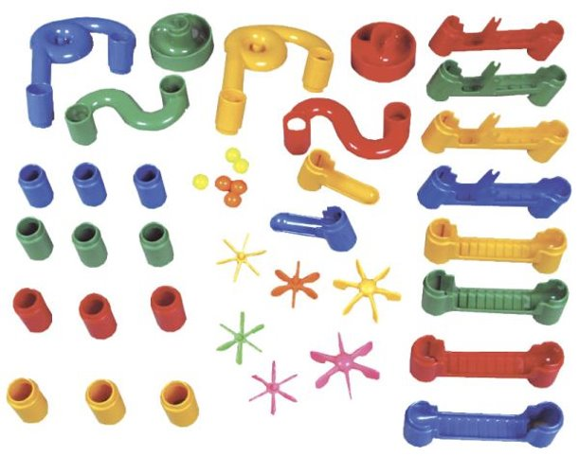 

## 6.2 Lighting

* Bright, to reflect on the plastic-like surfaces of the stage.

## 6.3 SFX/Music

List music clips and where they’re used.

* Fall ‘n’ Roll – Fall Guys (OST): used during the gameplay of the entire level.
* Didn’t Fall! (You Win) – Fall Guys (OST): plays during the end level cutscene.

List all sound effects and where they’re used.

* Rocket blast off

## 6.4 Particle FX

* Fire, for the spaceship taking off and for the sales platforms.

# 7.0 Level Asset List

<Static and dynamic objects relative to the environment>

|  |  |
| --- | --- |
| Item | Description |
| Marble | The unity material |

# 8.0 Delivery Milestones

<Provide milestone dates for Prototype, Testing Phases and Final Build>

**Prototype:** When will your first playable prototype of your level be ready? This will be a prototype/grey-box that will show off how your level works.

**Testing and Iteration:** You will need to test your level, get feedback, and make changes to your level and design based on your testing results. Allocate time for this to be done and complete.

**Final Build:** The final polished and complete build of your game.